Daily Stand-up Meeting
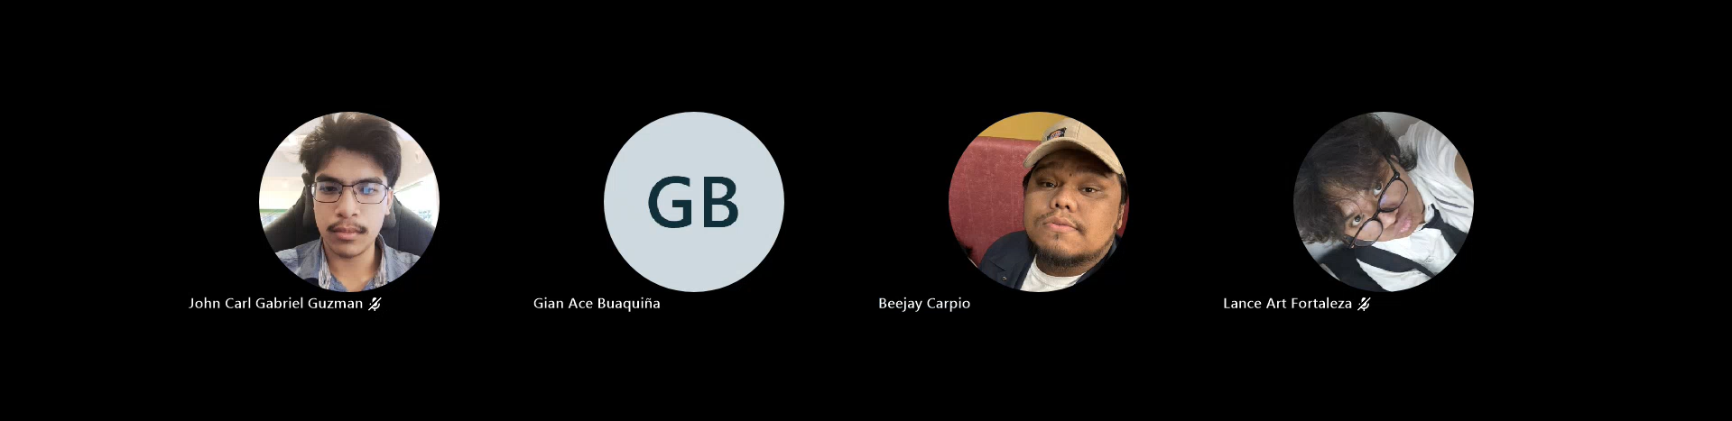
Minutes of meeting
Date: 09/21/2026
Meeting Called By: Cache Flow
Meeting Link: Daily Stand-Up Meeting-20260921_211820-Meeting Recording.mp4

Attendees
Gian Ace Buaquiña
Beejay A. Carpio
Lance Art P. Fortaleza
John Carl Gabriel Guzman

Summary
discussed merging or migrating prototype commits from Gian's secondary GitHub repository back into Sir Sean's official project repository to ensure commit history is properly tracked. On deployment, the team noted Sir Sean's instruction to host the cloud prototype on APC's Proxmox environment, with plans to consult Sir Sean on Thursday regarding exact server access. Lastly, the team aligned on finalizing current use case tasks before moving to subsequent modules to prevent task carryover into Sprint 2.

What we did yesterday (Last Friday):
- Beejay A. Carpio: Completed C4 system diagrams, updated user stories, and worked on fully dressed use case revisions.
- Gian Ace Buaquiña: Updated the GitHub organization, updated the Excel tracker file with new task items, and researched deploying Lira on a local virtual machine.
- John Carl Gabriel Guzman: Completed the three Minutes of Meeting (MOM) documents for prior sprint meetings.
- Lance Art P. Fortaleza: Continued frontend development for student-side catalog views and book details.

What we did today:
- Beejay A. Carpio: Drafted the student/faculty search walkthrough Activity Diagram on Draw.io and restructured the product backlog to separate CRUD operations into distinct columns (Create, Read, Update, Delete) per Sir Sean's instructions.
- Gian Ace Buaquiña: Investigated system integration workflows between the prototype and Koha.
- John Carl Gabriel Guzman: Updated documentation logs on SharePoint and compiled the individual work breakdowns for the meeting minutes.
- Lance Art P. Fortaleza: Continued frontend UI task execution.

